CREATE JAVA APPLICATION

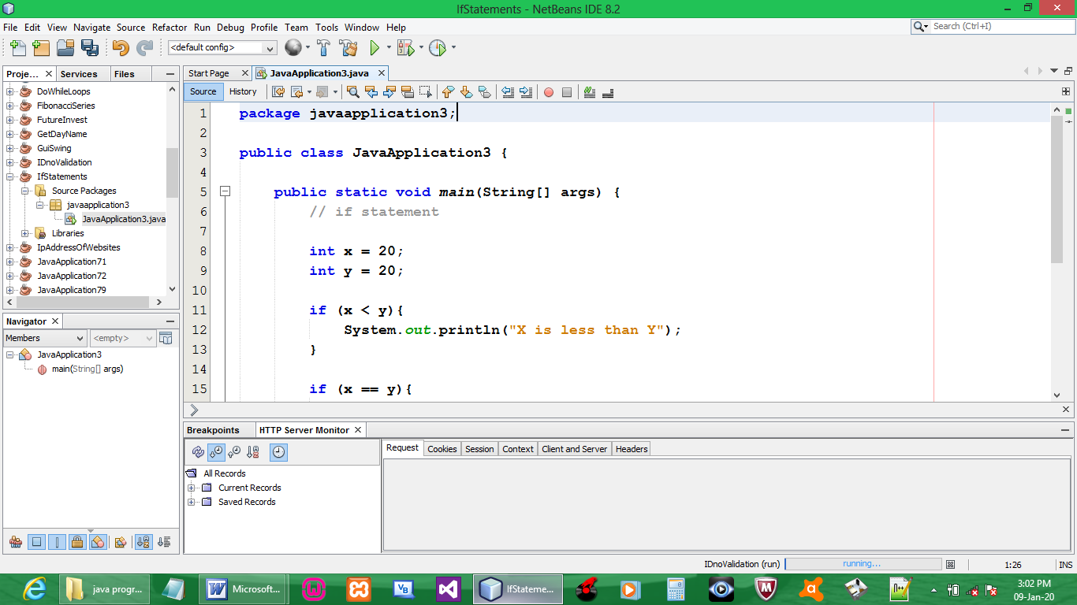

CODE:

package javaapplication3;

public class JavaApplication3 {

public static void main(String[] args) {

int x = 20;
int y = 20;

if (x < y){
System.out.println("X is less than Y");
}

if (x == y){
System.out.println("X is equal to Y");
}

if (x > y){
System.out.println("X is greater than Y");
}
}
}

OUTPUT:

